-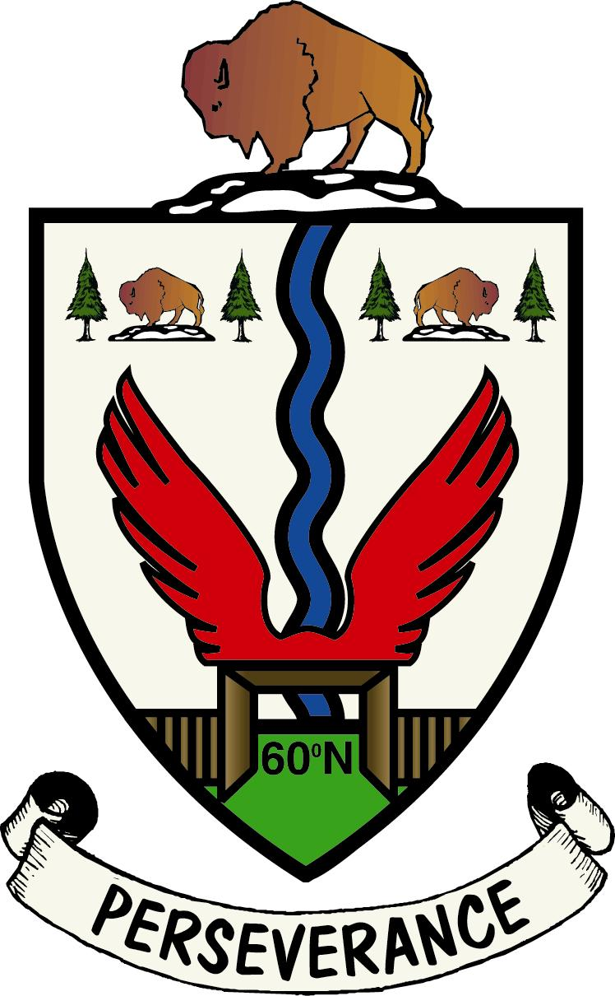
Town of Fort Smith
Town Council Meeting
Agenda

October 18, 2022, 7:00 p.m. – Council Chambers

- Call to Order and Confirmation of Quorum
- Approval of Agenda
- Presentations
  - RCMP Police Report September 2022
  - Barkley Heron

- Approval of Council Minutes
- Council Minutes 09-22

- Business Arising from the Minutes
- Declaration of Financial Interest
  - Statement of Disclosure of Interest
- Council Business
- Introduction and Consideration of
Committee Reports
    - Corporate Services
    - Community Services
    - Municipal Services
- Enactment of Bylaws and Policies
I .Bylaw # 1037
ii. Bylaw # 1038
iii. Bylaw # 1039

- Appointments
- Lands Development Officer

- Mayor and Council/Board Representative Update

- Administration
i. Burton Appeal Descision

- Proclamations
- Absence of Council Members
- Date of Next Council Meeting
- Adjournment
- Question Period

